# GRL Model of Transcript 6

Traceability links to underlying arguments are shown with green and red dots.

* A green dots means that the element or relationship corresponds to an accepted argument in an underlying argumentation network
* 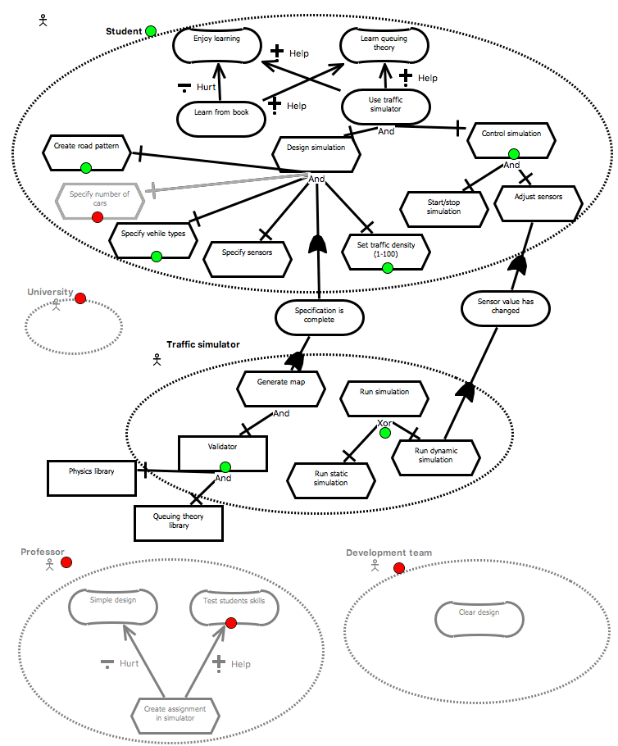A red dots means it is rejected (the element is grayed out).

# Some remarks

* The argument schemes we proposed do not all occur in the transcripts.
* An important reason for this is probably that the students did not construct a goal model, rather they were using some other methodology.
* We found various argument schemes and argumentation patterns that are not supported by our formalism:
  + *Clarification.* Someone proposes an element/relation and someone else asks for clarification. The first person responds with a new description which replaces the first one.
  + *Context-dependent reason for attack:* Some element is attacked in a way that is context-dependent. For instance "It is not part of the problem statement", or "we already have a similar element". Or somone can just propose an alternative description that is deemed more appropriate.
* Furthermore there are various elements and relationships we did not address in the argument schemes, such as:
  + *Attack on actor:* Some actor may be deeemd irrelevant, which disables all child elements and relationships.
  + *Attack on decomposition*
  + *Attack on element outside of actor.*

Next we show them in more detail.CLARIFICATION ATTACK

**GRL Element Arguments**

AS2: Actor *student* can perform task *choose a pattern*



CQ?:?? (clarification request)

*P2: I'm not sure what you mean by "choose a pattern". I thought just pick roads, varying sizes, etc.*

AS2: Actor *student* can perform task *choose a pattern preference*

P1: You provide users with different types of roads. How about pattern prefernece?

CQ?:?? (clarification request)

*P2: It's still not clear to me, what kind of pattern?*

AS2: Actor *student* can perform task *choose a road pattern*

P1: A road pattern

**Analysis:**

* We don't have a "clarification" step in PRAS. However, this is something that happens often in the discussion in the transcripts. How to accommodate this?
* So the first argument is accepted, but the name of the action is replaced by the content of the last argument.

## GENERIC (CONTEXT-DEPENDENT) ATTACK

**GRL Element Arguments**



CQ?:?? (redundancy)

*P2: Density is the same as number of cars, so we can remove this one.*

AS2: Actor *student* can perform task *specify number of cars*

**Analysis**

* In this case we have a task that already exists under a different name. The only argument scheme we have to attack a task is: CQ2. Is the task possible? However, we seem to need a different one here.

**GRL Element Arguments**

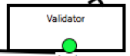

CQ?:??

*P1: The validator functionality is internal, but uses external libraries.*

AS?: Resource *Validator* is an external resource

**Analysis**

* We also don't have critical questions or argument schemes for elements that are not part of an actor.

**GRL Element Arguments**

AS3: Actor *student* has task *set traffic density in two options: busy road or seldomly used road*

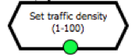

CQ?

*P3: It should allow any variation in between, so use integer 1-100*

**GRL Element Arguments**

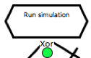

AS?: Task *run simulation* AND-decomposes into *run static simulation* and *run dynamic simulation*

AS3: Task *run simulation* XOR-decomposes into *run static simulation* and *run dynamic simulation*

*P2: While the simulator should be able to do both things, it cannot do both at the same time. So it should be a XOR-decomposition.*

**Analysis**

* We don't have argument schemes for task decomposition
* Here an argument schemes attacks another one since they cannot occur at the same time.

**GRL Element Arguments**

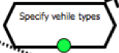

AS3: Actor *student* has task *set vehicle type*

The weight and size is too specific. Rather let them choose "truck" or "small car", etc.

AS3: Actor *student* has task *set the weight and size of the car*

**Analysis:**

* Again two argument schemes that are conflicting, but one has preference and is motivated.

# 

## ATTACK ON ACTOR

**GRL Element Arguments**

CQ?

*P2: Let's not make things to difficult. Development team doesn't seem relevant now.*

AS?: *Development team* is a relevant actor in the system.

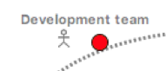

**Analysis**

* We don't have argument schemes or critical questions for actors alone.

**GRL Element Arguments**

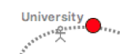

AS?: *University* is a relevant actor in the system.

CQ?

*P1: University is the environment and not a stakeholder.*

**Analysis:**

* Same as with "Development team"

**GRL Element Arguments**

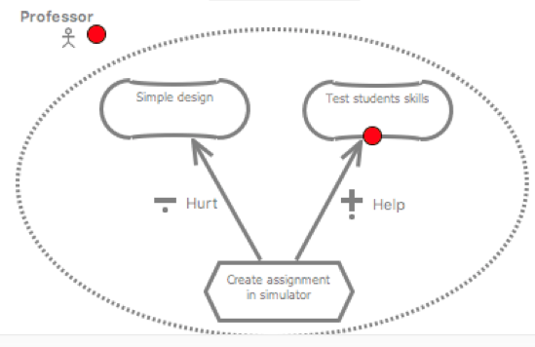

AS3: Actor *professor* has goal *test students skills*

CQ?

*P3: This is not part of the problem specification.*

AS?: *Professor* is a relevant actor in the system.

CQ?

*P1: The professor would like to have the tool but does not use it. So she is not relevant for now.*

**Analysis**

* We only have the critical question "Can the desired goal be realized?" for AS3. However, it's not applicable here.
* If an actor turns out to be irrelevant, all elements in the actor should be disbled.